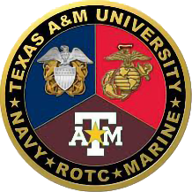
Navy Option NROTC College Programmer Application
Direct Questions to your Cohort advisor based on your Grad Date:
Fall 2026 or Spring 2029: LT Ramirez ahramirez@tamu.edu
Fall 2027 or Spring 2028: LT Jolley jjolley@navy.tamu.edu
Fall 2026 or Spring 2027: LT Trevino ttrevino@navy.tamu.edu
- What is your name, school year, graduation date and school email?

- Are you a member of the Corps of Cadets? If so, which Outfit and what is your current billet?

- Are you enrolled in, or are you eligible for, the Hazelwood Act scholarship?

- What is your major? Have you completed Calculus or Physics?

- What was your high school GPA? If applicable, what is your college GPA?

- What was your SAT or ACT score? If you took the ASVAB, what was your score?

- Did you hold any leadership positions in high school? Do you hold any leadership positions in the Corps of Cadets?

- Do you have any volunteer hours? If so, how many?

- Did you have any family members serve in the military? If so, what branch did they serve in, and what rank did they obtain?

- In 100 words or less, why do you want to be a Naval Officer?

Email your application and current transcript by Tuesday 1200, 4 February to your Military advisor (as outlined above).
*** Late and/or incomplete applications will not be accepted ***

